As a prelude to Mental Health Awareness Week…
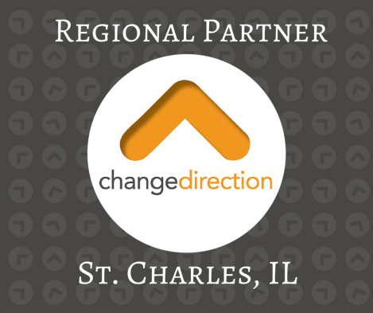
PRESENTS:

Teens Campaign to Change Direction
Saturday, October 3
FREE EVENT!
9:15*-10:45 am
Arcada Theater in St. Charles, IL
^{*(doors open at 9 am)}
Join Creekwood staff moderating a panel of teens sharing their
journey through mental health.
An event to celebrate mental health education, awareness, and recovery.

Join the conversation. Change Direction. #ChangeMentalHealth

TICKETS @ EVENTBRITE: teens campaign to change direction
Change Direction - St. Charles, IL regional effort
www.changedirection.org

